Supplementary Material

a) b)

Figure S1: (a) 3-electrode system with 0.6 M of HCl (b) Hydrogel supercapacitor schematic diagram (NCH: NCH1, NCH2, NCH3)

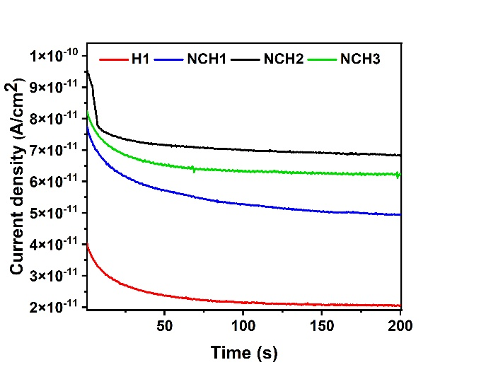  a) | 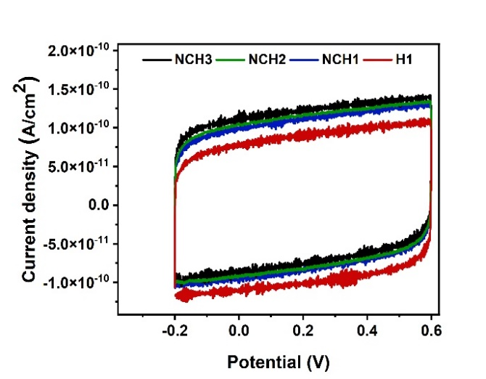  b)
Figure S2: (a) Current density of different samples H1, NCH1, NCH2, and NCH3 (b) Cyclic voltammetry of H1, NCH1, NCH2, and NCH3 samples

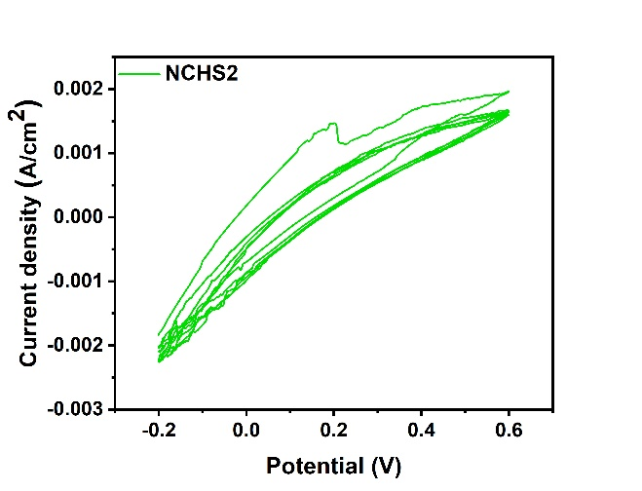  a) | 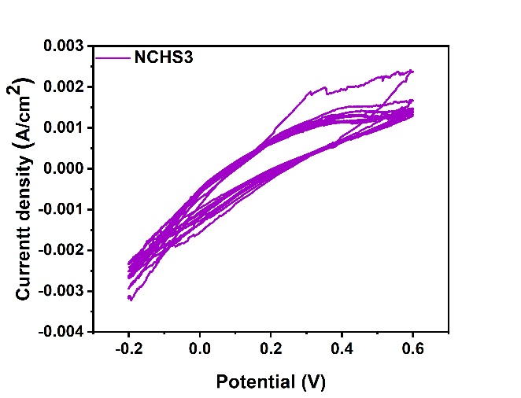  b)
Figure S3: The cyclic voltammetry curve of the (a) NCHS2 and (b) NCHS3 samples under many cycles

The composition and ratio of the hydrogel nanocomposite used in this study are as follows:

1. Reduction of GO:
1.0% of GO was first dissolved in deionized water using ultrasonication. Then, 100 mg of ascorbic acid was slowly added to convert GO to RGO.

Name | % mass | mass
Arabic gum (from acacia tree-branched polysaccharide) | 36.601% | 1.2g
Acrylic acid | 60.002% | 2g
APS (initiator) | 1.5% | 0.05g
2. Preparation of Arabic gum-polyacrylic acid hydrogel:
1.2 g of AG was completely dissolved in 10 ml of deionized water, then 2 ml of AA solvent was slowly added. After 10 minutes, 0.082 g of FeCl₃ and 0.05 g of APS were added to the hydrogel matrix. Then, keep stirring at 40 °C for 2 hours. Table S(1) shows the mass and percentage of each component in the hydrogel.

Table S1: Composition of the hydrogel

3. Preparation of RGO-AgNPs-AGPAA hydrogel:
The AgNO₃ (1.0%, 0.5%, 0.1%) and 4 ml of solution (1) were slowly added to the hydrogel matrix (2) respectively and then allowed to stir at 90°C for 1 hour. Table S(2) shows the mass and percentage of each component in the nanocomposite hydrogel.

Table S2: Composition of the nanocomposite hydrogel

Name | Amount used
Arabic gum | 33.42%
Acrylic acid | 58.54%
APS | 1.39%
GO | 1%
Ascorbic acid | 5.57%
Ag⁺ | 0.1%

