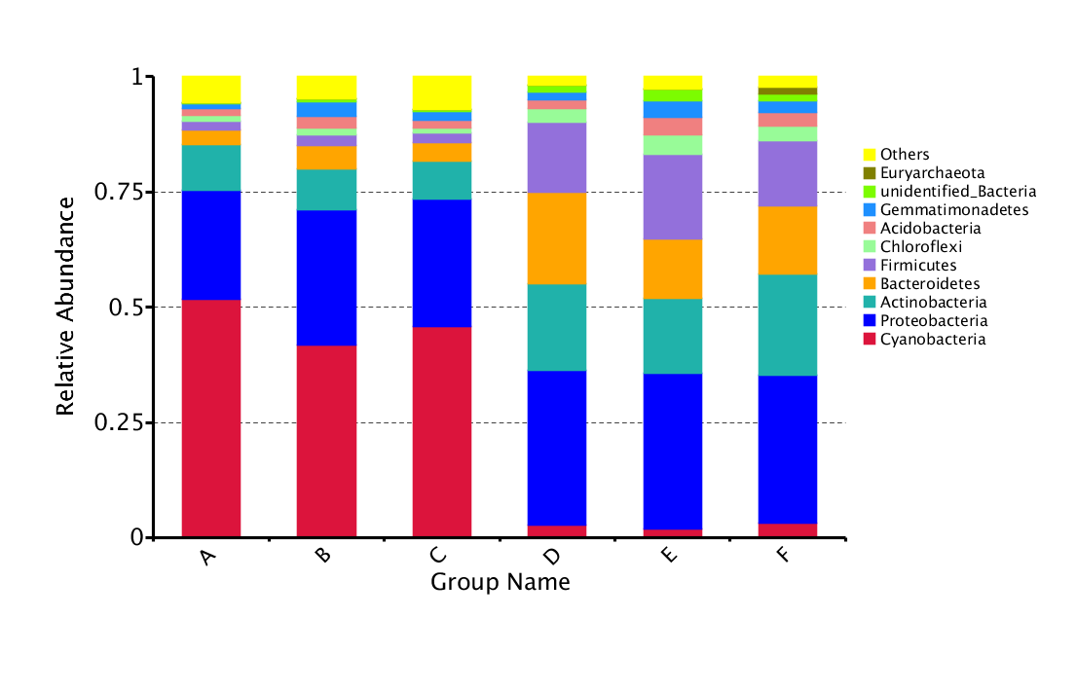(a)

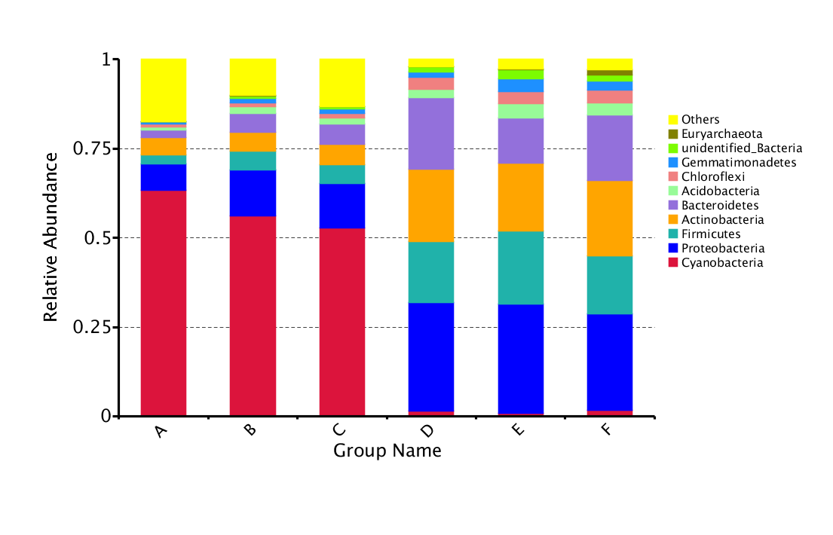(b)

**Figure S1: Relative abundance of the top 10 phyla of microbiomes of the two the wild plant species *A. fruticosum* and *N. vermiculata*.**

Relative abundance of the top 10 phyla of microbiomes collected from rhizospheres (microbiome groups D, E & F) of *Abutilon fruticosum* (a) and *Nitrosalsola vermiculata* (b) and their surrounding bulk (microbiome groups A, B & C) soils in three replicates after 0 (A & D, respectively), 24 (B & E, respectively) and 48 h (C & F, respectively) of watering.**Figure S2: Predicted KEGG pathways at levels I and II of microbiomes of *A. fruticosum*.**

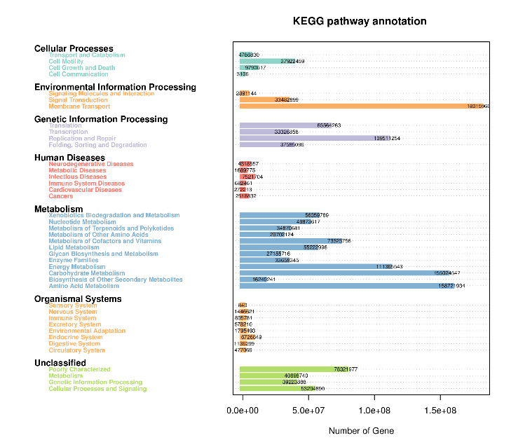

***A. fruticosum***

Predicted KEGG pathways at levels I and II referring to the number of genes across bulk and rhizosphere soil microbiomes, on one hand, and across time after watering, on the other hand, of the wild plant species *A. fruticosum*.

**Figure S3: Predicted KEGG pathways at levels I and II of microbiomes of *N. vermiculata*.**

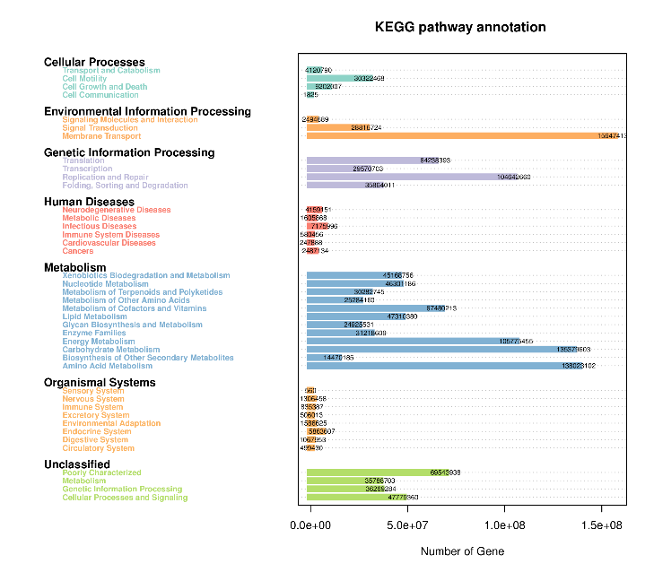

***N. vermiculata***

Predicted KEGG pathways at levels I and II referring to the number of genes across bulk and rhizosphere soil microbiomes, on one hand, and across time after watering, on the other hand, of the wild plant species *N. vermiculata*.

**Figure S4: Abundance of the top 10 predicted level-III KEGG pathways of microbiomes of *A. fruticosum*.**

Abundance of the top 10 predicted level-III KEGG pathways within grouping style ABCDEF microbiomes collected from surrounding bulk (grouping style ABC) and rhizosphere (grouping style DEF) soils of *A. fruticosum* after 0 (groups A & D, respectively), 24 (groups B & E, respectively) and 48 h (groups C & F, respectively) of watering. Red arrows refer to highly enriched pathways in rhizosphere soil microbiome.

**Figure S5: Abundance of the top 10 predicted level-III KEGG pathways of microbiomes of *N. vermiculata*.**

Abundance of the top 10 predicted level-III KEGG pathways within grouping style ABCDEF microbiomes collected from surrounding bulk (grouping style ABC) and rhizosphere (grouping style DEF) soils of *N. vermiculata* after 0 (groups A & D, respectively), 24 (groups B & E, respectively) and 48 h (groups C & F, respectively) of watering. Red arrows refer to highly enriched pathways in rhizosphere soil microbiome.

**Figure S6: Heat map referring to the top 35 KEGG level III pathways of microbiomes of *A. fruticosum*.**

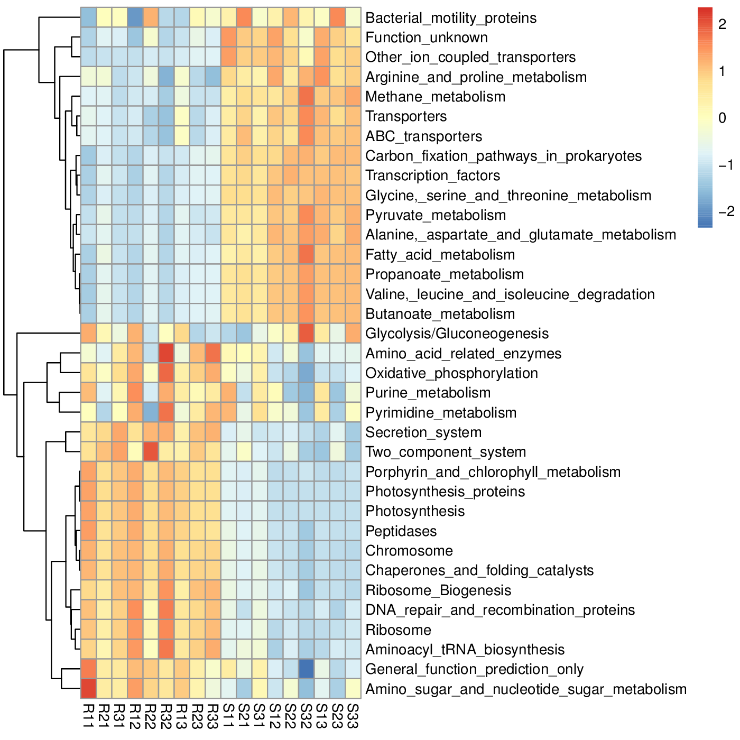

*A.* *fruticosum*

Heat map referring to the top 35 KEGG level III pathways in terms of enrichment at the individual samples level for microbiome collected from surrounding bulk (samples S11-S33) and rhizosphere (samples R11-R33) soils of *A. fruticosum* after 0 (S11-S13 & R11-R13, respectively), 24 (S21-S23 & R21-R23, respectively) and 48 h (S31-S33 & R31-S33, respectively) of watering.

**Figure S7: Heat map referring to the top 35 KEGG level III pathways of microbiomes of *N. vermiculata*.**

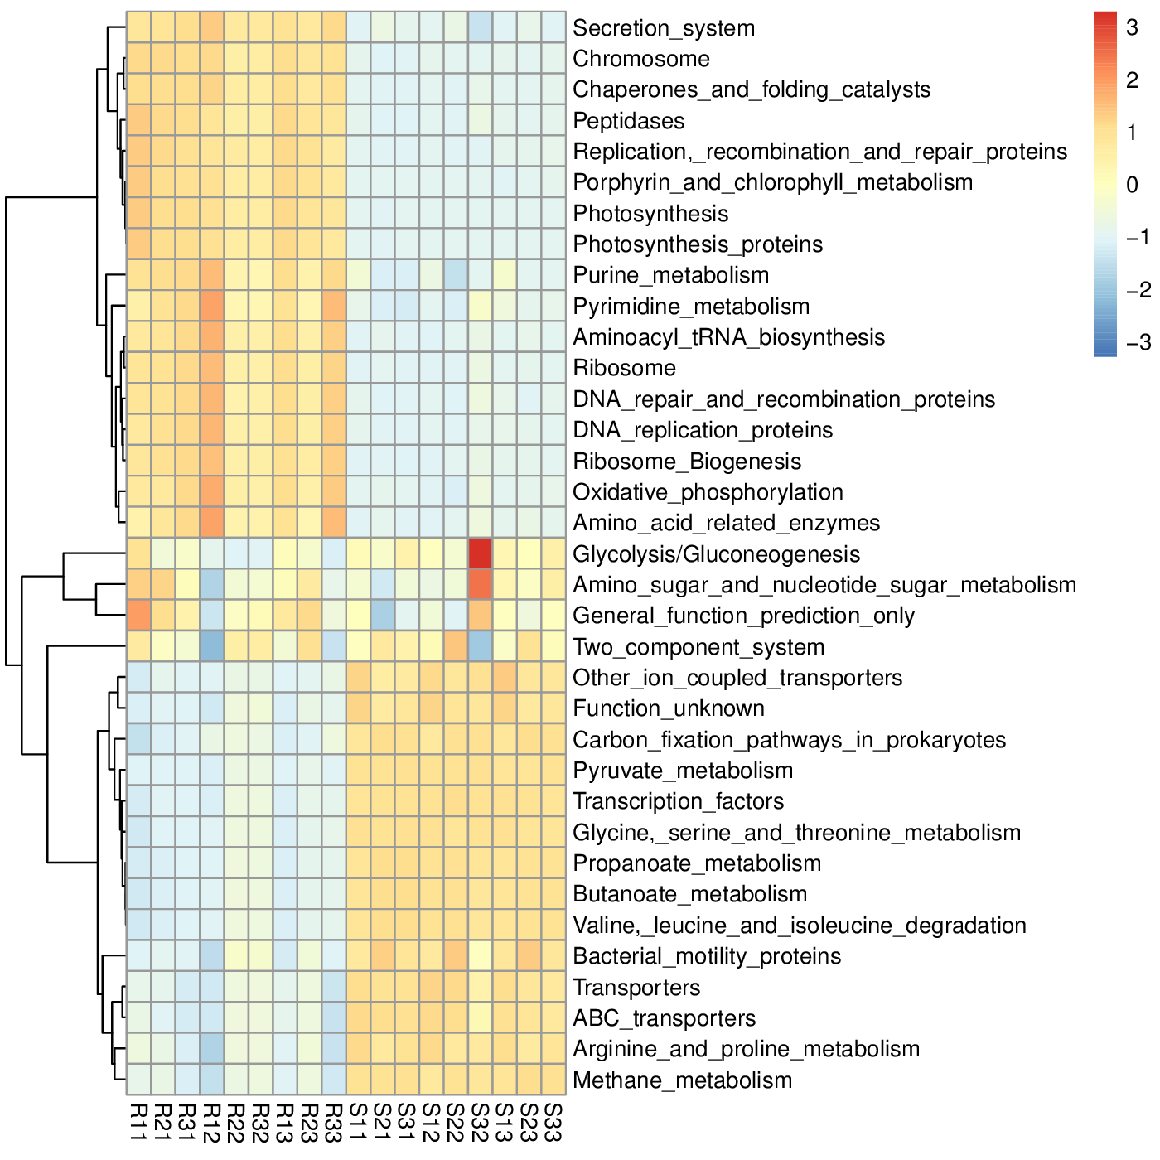

*N.* *vermiculata*

Heat map referring to the top 35 KEGG level III pathways in terms of enrichment at the individual samples level for microbiome collected from surrounding bulk (samples S11-S33) and rhizosphere (samples R11-R33) soils of *N. vermiculata* after 0 (S11-S13 & R11-R13, respectively), 24 (S21-S23 & R21-R23, respectively) and 48 h (S31-S33 & R31-S33, respectively) of watering.

**Figure S8: Predicted level-III KEGG pathways of microbiomes of *A. fruticosum*.**



Predicted level-III KEGG pathways (34) of microbiomes collected from surrounding bulk (So1) and rhizosphere (Rh1) soils of the wild plant species *A. fruticosum*. Columns with faint colors refer to pathways that showed no tendency towards any of the two types of soils. Red arrow refers to one of the top 10 predicted level-III KEGG pathways with ≥ 1.5-fold enrichment in rhizosphere soil microbiome.

**Figure S9: Predicted level-III KEGG pathways of microbiomes of *N. vermiculata.***



Predicted level-III KEGG pathways (34) of microbiomes collected from surrounding bulk (So1) and rhizosphere (Rh1) soils of the wild plant species *N. vermiculata.* Columns with faint colors refer to pathways that showed no tendency towards any of the two types of soils. Red arrow refers to one of the top 10 predicted level-III KEGG pathways with ≥ 1.5-fold enrichment in rhizosphere soil microbiome.

**Figure S10: Heat map referring to the top 35 enriched compounds of microbiomes of *A. fruticosum*.**

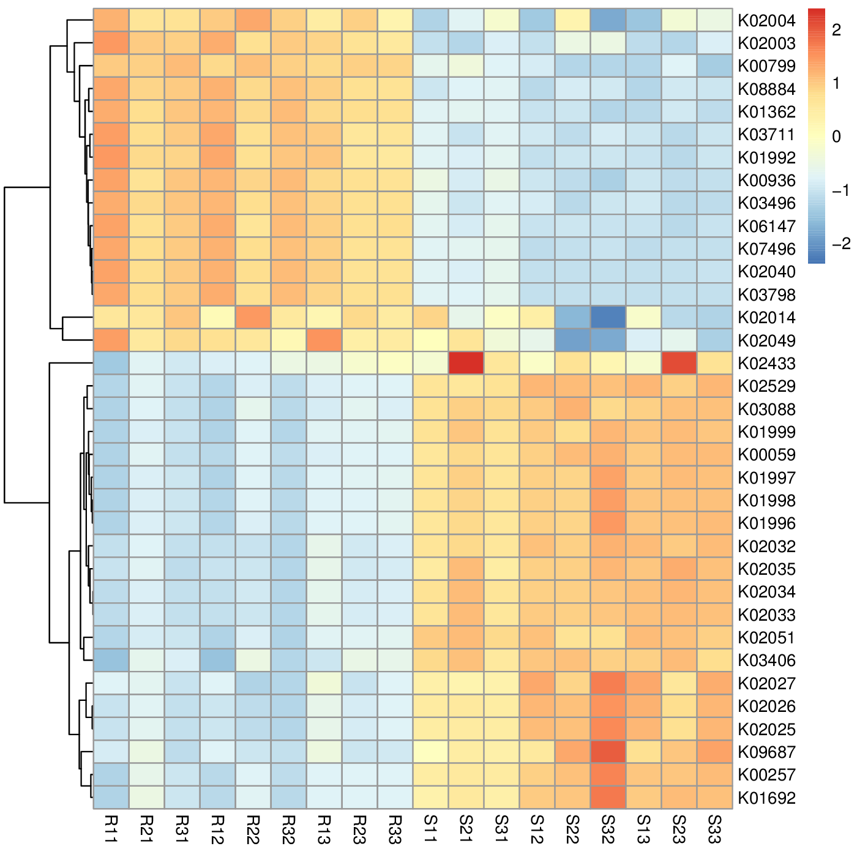

*A.* *fruticosum*

Heat map referring to the top 35 enriched compounds at the individual samples level for microbiome collected from surrounding bulk (samples S11-S33) and rhizosphere (samples R11-R33) soils of *A. fruticosum* after 0 (S11-S13 & R11-R13, respectively), 24 (S21-S23 & R21-R23, respectively) and 48 h (S31-S33 & R31-S33, respectively) of watering.

**Figure S11: Heat map referring to the top 35 enriched compounds of microbiomes of *N. vermiculata*.**

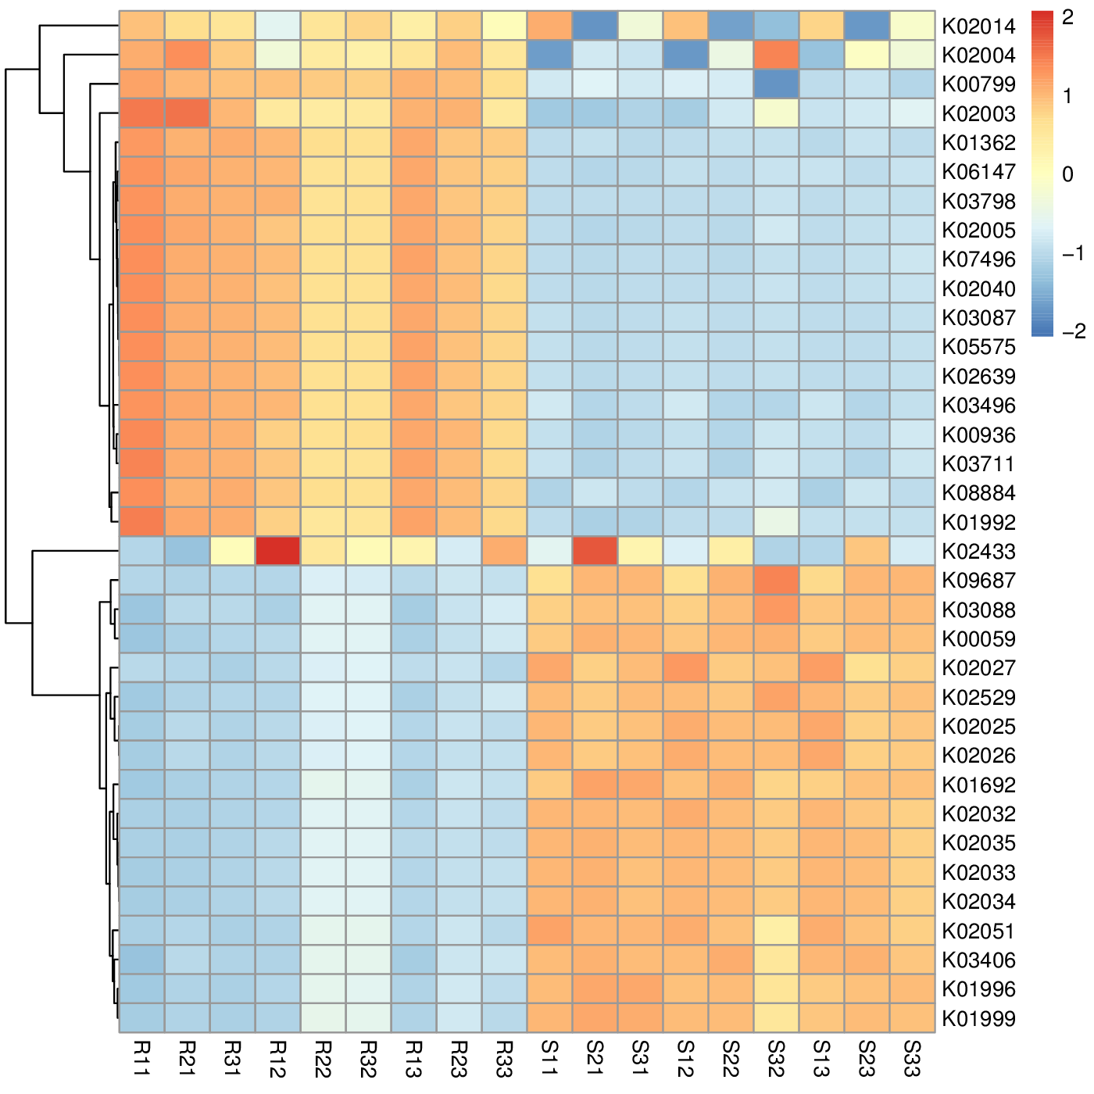

*N.* *vermiculata*

Heat map referring to the top 35 enriched compounds at the individual samples level for microbiome collected from surrounding bulk (samples S11-S33) and rhizosphere (samples R11-R33) soils of *N. vermiculata* after 0 (S11-S13 & R11-R13, respectively), 24 (S21-S23 & R21-R23, respectively) and 48 h (S31-S33 & R31-S33, respectively) of watering.

**Figure S12: Enriched compounds of predicted level-III KEGG pathways of microbiomes of *A. fruticosum*.**



Enriched compounds (27) of predicted level-III KEGG pathways of microbiomes collected from surrounding bulk (So1) and rhizosphere (Rh1) soils of the wild plant species *A. fruticosum*. These compounds commonly presented in the wild two plants. Columns with faint colors refer to pathways that showed no tendency towards any of the two types of soils. Red arrows refer to compounds (7) participating in one or more KEGG pathways in microbiomes of the two wild plants (see Table S2) with ≥ 1.5-fold enrichment in one soil type than the other (see Figures S8 & S9).

**Figure S13: Enriched compounds of predicted level-III KEGG pathways of microbiomes of *N. vermiculata.***



Enriched compounds of predicted level-III KEGG pathways of microbiomes collected from surrounding bulk (So2) and rhizosphere (Rh2) soils of the wild plant species *N. vermiculata*. These compounds commonly presented in the wild two plants. Columns with faint colors refer to pathways that showed no tendency towards any of the two types of soils. Red arrows refer to compounds (7) participating in one or more KEGG pathways in microbiomes of the two wild plants (see Table S2) with ≥ 1.5-fold enrichment in one soil type than the other (see Figures S8 & S9).

**Figure S14: Enriched compounds in one or more KEGG pathways in microbiomes of *A. fruticosum.***

***A.* *fruticosum***



Enriched compounds (7) in one or more KEGG pathways in soil microbiomes of *A. fruticosum* with ≥ 1.5-fold enrichment in one soil type than the other. Samples were collected from surrounding bulk (grouping style ABC) and rhizosphere (grouping style DEF) soils after 0 (groups A & D, respectively), 24 (groups B & E, respectively) and 48 h (groups C & F, respectively) of watering.

**Figure S15: Enriched compounds in one or more KEGG pathways in soil microbiomes of *N. vermiculata.***

***N.* *vermiculata***



Enriched compounds (7) in one or more KEGG pathways in soil microbiomes of *N. ver miculata* with ≥ 1.5-fold enrichment in one soil type than the other. Samples were collected from surrounding bulk (grouping style ABC) and rhizosphere (grouping style DEF) soils after 0 (groups A & D, respectively), 24 (groups B & E, respectively) and 48 h (groups C & F, respectively) of watering.

**Figure S16: Results of real time PCR of the *gatA* gene in microbiomes of *A. fruticosum* and *N. vermiculata.***

Results of real time PCR of the *gatA* gene encoding dual-specific aspartyl-tRNA(Asn)/glutamyl-tRNA (Gln) amidotransferase subunit A of *Bacillus subtilis* str. 168 (GenBank acc. no. AL009126.3) relative to its 16S rRNA (AB042061) gene used as the house-keeping gene enriched in bulk (groups A, B & C) and rhizosphere (groups D, E & F) soil microbiomes of *A. fruticosum* and *N. vermiculata* at 0 (groups A & D), 24 (group B & E) and 48 h (groups C & F) of watering.